LUBIRI SECONDARY SCHOOL
END OF TERM II EXAMINATIONS 2009
MATHEMATICS
SENIOR ONE
TIME: 1 ½ HOURS

- ATTEMPT ALL QUESTIONS.

1. Simplify: 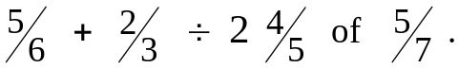

2. Solve: 5 – 2 (x – 3 ) = 23.

3. Complete the following sequences;

(i). 1, 4, 9, 16, _____, _____, _____

(ii). 1, 3, 6, 10, _____, _____, _____

4. Find the value of the letters marked in the diagram below:

40⁰
\ /

m n

5. Find the LCM and HCF of 24, 27 and 54.

6. Convert the following fractions into decimals:
(i). 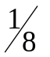 (ii). 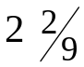

7. Convert 0.7272 -------- to a fraction.

8. Study the figure below and answer the questions that follow;

(x + 4) cm (x – 3) cm (a). Find the value of x. (b). Use the value of x and find the (i). Perimeter
2(x – 3) cm (ii). Area.
9. Using a ruler and a pair of compasses only, construct a triangle ABC, in which 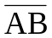 = 6 cm, 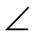CAB = 45º and CBA = 75º.

(a) Measure: (i). 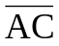 (ii). 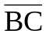 (iii). ACB.

(b) Construct a circum circle and measure its radius.

10 (a). John used 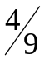 of his monthly income on food and 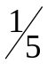 of the remainder on clothings. If he realized a balance of twelve thousand shillings, how much was his income?

(b). Three bells ring at different times. Bell A rings after every 5 minutes, B rings after every 10 minutes and C rings after every 16 minutes.
After how many minutes will the bells ring together?

END.

